**KNBMS Technical Consulting**

**BART Physical Security Information Management System**

**Final Report**



**Prepared By:**

**Harneik Dhanota**

**Simranjeet Kaur**

**Monisha Kaur**

**Brixton Pizzuti**

**Kerwin Garcia**

**Table of Contents**

**Project Team Charter…………………………………………………………….3**

**Project Business Case……………………………………………………….........6**

**Scope Management Plan…………………………………………………….......20**

**Work Breakdown Structure…....……………………………………………….31**

**Project Schedule and Budget…………………………………………………....39**

**Lesson-Learned Reports………………………………………………………...42**

**Team Charter**

**Team Members**

Name | Phone Number | Email

Harneik Dhanota | 408-839-1104 | nick83016@gmail.com

Brixton Pizzuti | 949-878-8736 | brixtonpizzuti@gmail.com

Kerwin Garcia | 925-759-8382 | kerwinrandolph7@gmail.com

Monisha Kaur | 510-673-0216 | miakaur.wit@gmail.com

Simranjeet Kaur | 510-598-5723 | skaur4376@gmail.com

**Team Mission**

The mission of ‘KNBMS Tech Consulting’ is to accurately complete every project in a timely manner while maintaining a positive relationship with the client at hand.

**Meeting Times**

● Every Monday 12:30 to 1:30pm - Library/TBD

● Every Wednesday 12:30 to 1:30pm - Library/TBD

We will only have scheduled meetings in person for urgent matters, most of our meetings will be through Skype or Google hangouts. We will have continuous communication through GroupMe (group chat application) or through iMessage.

**Project Overview**

KNBMS Technical Consulting plans on enhancing and implementing a Physical Security Information Management System (PSIMS) for the Bay Area Rapid Transit (BART). The scope of this project consists of enhancing about 1,500 existing analog video cameras for the Bay Area Rapid Transit (BART) to a fully digital format, which in turn would be linked to computers with real-time video analytics to notify dispatch/police officers of any criminal activity. Enhancing BART’s system security technology is a major initiative which aims to improve public safety. Our technology will be tested prior to implementation to ensure effectiveness. Implementation of this system could take up to 12 months, but BART ideally would like the project completed within six months, the 1,500 cameras that will be updated will first be tested in East Bay BART stations only. BART has stated they have a budget of approximately $4 million dollars for implementation and an additional $1.3 million for ongoing costs. Before this implementation takes place, BART will spend $15 million to upgrade all of their analog security cameras to digital. KNBMS feels this project would be effective and beneficial to the community since our system will help increase public safety through advanced video analytics software.

**List of Team Rules and Expectations**

1. Be on time for all meetings, no more than 5 minutes late.

2. Attend the full meeting time, unless it’s a serious emergency.

3. If a team member misses 3 meetings, we have the right to dock the person for lack of participation.

4. Stay on track through our meeting times, avoid off-topic conversations.

5. We expect all team members to allow one meeting without a verified emergency

6. We expect all team members to complete their responsibilities by the given deadline, otherwise affecting their evaluation negatively.

7. If a member needs to miss a meeting, he/she should let us know 48 hours in advance so we can reschedule our meeting.

8. If a team member shows up late and hinders the group’s performance, their evaluation will be affected negatively.

9. If there is conflict in the group, we will do our best to resolve the issue, and if we cannot resolve it, we will play rock paper scissors.

10. We expect team members to respect everyone’s opinions and discussions without shutting them down.

11. We expect all team members to contribute to the discussions and if they do not, his or her evaluation will be affected negatively.

12. We expect all team members to come to meetings using full effort and participation, so we can efficiently use our time together.

13. We expect all team members to have equal responsibility in this project, and to be honest with a team member if they are not contributing equally.

14. We expect for everyone to set deadlines for their tasks before its due, to allow time for revisions by the other members of the group.

15. We expect all team members to speak their mind and to not be passive in open discussions.

**Code of Ethics**

As a member of this group and as a humane member of this planet, each member of KNBMS Consulting should conduct their work in a courteous and professional manner at all times. We will respect our clients and make sure to maintain a positive relationship while executing our project in a timely manner. We will incorporate honesty, dedication, and loyalty into our projects to ensure positive relationships with our clientele.

**Honesty**

As a member of this group, you will never lie to the client and will fully disclose all information regarding this project.

**Dedication**

As a member of this group you make time and use maximum effort for our code of ethics, work, and other projects.

**Loyalty**

Every member must respect each other as well as sustaining the group’s efficiency.

**Agreement**

All members of KNBMS Tech Consulting will abide by the rules and principles this document details. The names below ensure that each member of the group understands and agrees to the contents listed in this charter.

**Signatures**

Brixton Pizzuti : Date: 9/16/18

Harneik Dhanota : Date:9/16/18

Kerwin Garcia : Date:9/16/18

Simranjeet Kaur: Date:9/16/18

Monisha Kaur : Date: 09/16/18

## **Business Case**

***Roles/Descriptions:***

|  |  |  |
| --- | --- | --- |
|  |  |  |
| Executive Sponsor | Provides executive support for the project | Harneik Dhanota, VP Operations |
| Technology Support | Provides all technology support for the project | Simranjeet Kaur, VP Information Technology |
| Process Improvement | Advises team on process improvement techniques | Kerwin Garcia, Process Team Lead |
| Project Manager | Manages the business case and project team | Monisha Kaur, Project Manager |
| Software Support | Provides all software support for the projects | Brixton Pizzuti, Software Group Lead |

***Team Mission***

“The mission of KNBMS Tech Consulting is to accurately complete every project in a timely manner while maintaining a positive relationship with the client at hand.”

## ***Executive Summary***

KNBMS Technical Consulting will be enhancing and implementing a Physical Security Information Management System (PSIMS) for the Bay Area Rapid Transit (BART). The Bay Area Rapid Transit (BART) is a public transportation system which serves the Bay Area. BART is a subway system that links San Francisco and Oakland as well as counties including Alameda, Contra Costa, Santa Clara and San Mateo. BART has had a rise in numerous violent incidents and homicides including the recent stabbing attack which killed 18-year-old Nia Wilson. By upgrading and improving BARTs surveillance cameras, we can prevent such tragedies from occurring. It is clear that BART must take action to enhance their security measures in order to protect the community. BART’s current PSIMS system is designed to monitor sensors and alarms, but with enhancement through advanced video analytics, BART will tremendously boost security and maintain the public’s safety. Enhancement of BART’s physical security information management system will monitor thousands of concurrent “real-time” video and immediately notify police dispatch of suspicious activity. Upgrading BART’s current PSIMS system is a major initiative which promotes safety and security for anyone utilizing BART’s services. KNBMS Tech Consulting feels this project will be of great value to BART as well as benefit the community.

**Business Objective/Project Goals**

The objective of KNBMS Technical Consulting for this particular project is to provide better efficiency, reliability, and security of the Bay Area through the use of BART’s services. KNBMS Technical Consulting sees this opportunity for the BART community by:

* Enhancing over 1,500 analog cameras to fully digital format
* Creating stronger communication among dispatch, police officers, and BART officials through cutting-edge technology
* Monitoring any suspicious/criminal activities 24/7 thus leading to reduction of crime
* Utilizing advanced surveillance technology for safer transportation overall

Based on our research our alternatives include:

1. Continue using our current system.
2. Partner up with third party security contractor Pinkerton Government Services.
3. Enhancing and improving existing systems in the most efficient way within project scope in the most scalable way. This will require the use of programs and apps that monitor criminal activity using video analytics from Athena and Avigilon.

**Physical Security Information Management System (PSIMS)**

Physical Security Information Management System (PSIMS) connects systems and data for expanding multiple control networks and control hubs.

PSIM uses: Collection, Analysis, Verification, Resolution, Reporting, Audit trail.

Collection: Software data collection from security devices and systems.

Analysis: Analysis on events, data, alerts and prioritize other situations.

Verification: Will use programs that enables users a quicker way to verify real situations.

Resolution: The system uses SOP (Standard operating procedure) which enables any officials and organizations to provide efficiency on complex routines. Its aim is to achieve quality and unify performance.

Reporting: The software tracks all data and information needed for reporting, training and other protocols for analysis .

Audit trail: It tracks other data and monitors how each operator interacts with the system.

PSIMS’s best practices include defining and setting a short and long term goals and track progress in terms of attainment.

Although BART does have a current PSIMS in place, it has proven to be ineffective due to the increase of criminal incidents in recent times. KNBMS sees a major opportunity to help BART grow and keep our communities safe through the enhancement of their PSIMS system.

KNBMS Technical Consulting envisions a primary objective for BART’s current PSIMS system:

* enhancing PSIMS through the use of cutting-edge video analytics software which in turn provides a high-level of security for all of BART’s customers

**Desired Areas of Impact**

The MOV table below lists the potential areas that this project will impact and summarizes the measurable organizational value of BART.

|  |  |  |  |
| --- | --- | --- | --- |
| **Organizational**  **Impact** | **Value** | **Metric** | **Time Frame** |
| **Strategic** | Increase reliability, reputation and BART’s image | Increase safety guidelines by 20% | **12 Months** |
| **Customer** | Aims to improve public safety and  privacy of riders | Overall violent crime rate on BART is down 9% | **12 Months** |
| **Financial** | Reduce BPD labor | Reduce patrolling by 5 hours. | **12 Months** |
| **Operational** | Reduce the scheduling cycle time. | Reduce six days a week 10-hours per day | **12 Months** |
| **Social** | Reduce the number of crimes. | 16% drop in the number of robberies. | **12 Months** |

On an average there are at least 1,659 crimes year-to-date in 2018 at BART. Through the implementation of this project, we can assure the crime rate to decrease and increase public safety. With our advanced technology, BART officials and the police department can track down any type of criminal activity within minutes and help bring justice.

**Social Impact:**

* Improve accuracy and efficiency within the PSIMS system.
* Improve BART reputation and Safety,
* Overall safety improvements within the transportation community
* Increased sales and revenue

**Privacy:**

* As this would be implemented, the social impact for society would rise. That including, ethical standards of privacy and personal data. This project anticipated that every data collected is only for security purposes. The transportation is a non-private own organization. Unlike Chinas Skynet and their privacy issues, we have non-disclosures policies for individuals and society overall.
* We can have different styles of approach for human rights and respect for privacy. As individuals know privacy is extremely important, We have a secured database that is protected. Data privacy can be achieved through technical and social solutions. Creating awareness for social solutions in BART areas, such as providing terms and conditions as well as uses of the data in the BART tickets/fares.
* We plan and safeguard data from any unauthorized access. The terms explain services of customer experiences and the right to use data for security purposes. In other words a trade off data for good transportation security.
* We can use Principles and codes of conduct. Principles such as Data Collection and Purpose Principle, Data Security Principle, Openness Principle, Transparency, Data Access, and Correction Principle—Data subjects must be given access to their personal data and allowed to make corrections if the data are inaccurate, (Accuracy and Retention Principle).
* We can use codes of conduct that use operational and other functions to make personal data important for the organization and community. It serves as a guide for stakeholders based on a set of rules and standards. A code of conduct for the organization and its security and accountability for protecting valuable data.

**Desired Value of Project**

After thorough analysis, we have concluded that this project will bring great value to our society through a better and faster security system. Providing quality security to our communities is very important to us, as society will rely on public transportation and utilize it more than commuting in cars. Efficiency and reducing the scheduling cycle time is important and safety. Currently, BART PD officers work nonstop, yet the crime rate is still on the rise. We want to reduce labor and increase efficiency through implementing highly advanced technological cameras, which in turn results in effectiveness and reliability.

**Total Cost of Ownership**

* Systemwide implementation could take 12+ months. Estimated cost is $4 million for implementation and $1.3 million in ongoing costs.
* Migration to an all-digital system of PTZ (Pan Tilt Zoom), Dome, Intercom and Multi Sensor cameras in BART stations, parking lots, and garages. Since some of BART cameras are analog, this effort would convert those units to HD digital cameras. It would cost approximately $15 million and take roughly four and a half years to fully complete.
* The initial cost estimate is $28 million.

**Total Benefits of Ownership**

* Improve accuracy and efficiency within PSIMS system
* Reduced labor costs
* Improve BARTS reputation
* Improve Rider Safety

**Alternatives**

KNBMS has conducted rigorous research internally, and we have come up with three alternatives for the current analog PSIMS system:

1. Continue with BART’s current analog system
2. Partner up with the third party security services company Pinkerton Government Services.

* The system would be installed at all 48 BART stations by Pinkerton’s alarm technicians then monitored by their operations control center staff at one of their monitoring centers. Yearly costs for having Pinkerton monitor camera systems 24/7 365 and run routine investigations for all 48 bart locations is estimated at around $500,000 per year. The cost for alarm technicians is going to be estimated at $40/hr and Programmers at $80/hr. .

1. Enhancing and improving existing systems in the most efficient way within project scope in the most scalable way. This will require the use of programs and cameras that monitor criminal activity using video analytics from Athena and Avigilon. Hardware varies in price but we estimate cameras, video analytics software and hardware costs to range between 6 and 7 million dollars. Technician costs are at $50/hr and Programmers at $80/hr.

**Analysis of Alternatives**

In this section we will be bringing up Total Cost of Ownership (TCO) and Total Benefit of Ownership (TBO) for each of the three alternatives mentioned above.

**TCO (Total Cost of Ownership)**

The following table shows the total cost of ownership for all the alternatives for the PSIMS upgrade project.

|  |  |  |  |  |
| --- | --- | --- | --- | --- |
| **Resource** | **Description** | **Alt 1** | **Alt2** | **Alt 3** |
| Personnel Time | **Alternative one:** BART PD 35/HR & 25/HR Camera Control Center 8 Hour shifts 24/7 & 365  **Alternative two:** Alarm technicians $40/HR 8 Hour shifts  **Alternative three:** Technician $50/HR 8 Hour shifts | $40,000,000 | $4,540,000 | $4,850,000 |
| Software | **Alternative two:** Honeywell EBI (Enterprise Building Integrator)  **Alternative three:** Avigilon (Avigilon Control Center) and Athena (Smart Camera Gun Control System) <https://athena-security.com/pricing/> |  | $1,500,000 | $2,650,000 |
| Programming | **Alternative two:** 60/HR  **Alternative three:** 80/HR |  | $2,500,000 | $6,400,000 |
| Training | **Alternative three:** 1 Week training for entire Security Staff @ $100,000 per day |  |  | $500,000 |
| Hardware | **Alternative two:** HD PTZ Cameras, Dome Cameras  **Alternative three:** HD PTZ (Pan Tilt Zoom), Dome, Intercom and Multi Sensor Cameras and Graphics Cards (<http://avigilon.com/products/video-surveillance/cameras/>) |  | $2,400,000 | $3,600,000 |
| Support & Maintenance | **Alternative two:** Monitoring /Investigations Center  $750 k / year  **Alternative three:** 3 Year Maintenance/ Upgrade Contract @ $1 Million for a three-year period of coverage. |  | $750,000 | $1,000,000 |
| **Total** |  | **$40,000,000** | **$11,690,000** | **$19,000,000** |

**Table 1 PSIMS - TCO**

As you can see in Table 1 above, the alternative with the highest total cost of ownership would be the option that we currently have in place alternative one. The lowest TCO that we have here is the second alternative at time of start up. These numbers are subject to change.

## 

## **Total Benefit of Ownership (TBO):**

## **In order to finalize the products the TBO is an effective tool.**

|  |  |  |  |  |  |  |  |
| --- | --- | --- | --- | --- | --- | --- | --- |
| **Benefits** | **Weights** | **Alt 1** | **Weighted Alt1** | **Alt2** | **Weighted Alt2** | **Alt3** | **Weighted Alt3** |
| **Functional** |  |  |  |  |  |  |  |
| Track Advanced Analytics | 10 | 1 | 0.1 | 7 | 0.7 | 10 | 1 |
| Tracks Accurate Responses from PD | 10 | 2 | 0.2 | 5 | 0.5 | 10 | 1 |
| Accurately Follows Suspicious Activity | 10 | 3 | 0.3 | 8 | 0.8 | 10 | 1 |
| Improved Video Quality | 5 | 0 | 0.05 | 8 | 0.4 | 10 | 0.5 |
| Reduced Labor Costs | 7.5 | 0 | 0 | 8 | 0.6 | 8 | 0.6 |
| Improves Rider Safety | 15 | 0 | 0 | 8 | 1.2 | 9 | 1.35 |
| Improves BART Reputation | 7.5 | 0 | 0 | 9 | 0.675 | 10 | 0.75 |
| **Usability** |  |  |  |  |  |  |  |
| Availability | 5 | 6 | 0.3 | 9 | 0.45 | 8 | 0.4 |
| Security | 15 | 7 | 1.05 | 9 | 1.35 | 10 | 1.5 |
| Scalability | 10 | 7 | 0.7 | 10 | 1 | 10 | 1 |
| Operator Friendly | 5 | 8 | 0.4 | 10 | 0.5 | 8 | 0.4 |
| **Weighted Benefits** | **100** |  | **3.1** |  | **8.175** |  | **9.5** |

**Recommendation/Cost Benefit/ROI Analysis**

This cost benefit chart displays the cost of each alternative while also displaying the weighted benefits, here we can see the alternative 3 will give us the greatest benefit, but not the best ROI.

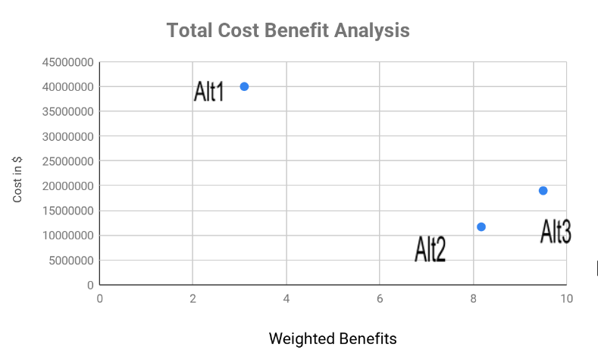

|  |  |  |  |  |
| --- | --- | --- | --- | --- |
| **ROI Chart - 12 Months** | | | | |
| Scenario | Cost | Revenue | Profit | ROI |
| Alt1 | $40,000,000 | $359,100,000 | $319,100,000 | 7.97% |
| Alt2 | $11,690,000 | $391,419,000 | $379,729,000 | 32.48% |
| Alt3 | $19,000,000 | $391,419,000 | $372,419,000 | 19.60% |

It can be found in the data that Alt3 has the highest TBO score compared to the other two alternatives. Alternative 3 improves BART’s security while enhancing and improving existing systems in the most efficient way within project scope in the most scalable way using advanced video analytics. Alternative 1 was keeping all of the analog cameras in place which would have cost us $40 million, while alternative 2 is to hire a third party security company to oversee all of BART’s stations. Alternative 2 cost us $11.7 million while alternative 3 would cost us $19 million. After thorough analysis, KNBMS Consulting has decided to pick alternative 3 due to cost efficiency, while also keeping all of our systems in house rather than outsourcing to a third-party company.

**Resources:**

* **People**

|  |  |  |
| --- | --- | --- |
| **Role** | **Description** | **Name** |
| Executive Sponsor | Senior level position which holds overall accountability for the project- ensuring business needs and benefits are upheld and met to the highest standard of the organization | Harneik Dhanota, VP Operations |
| Technology Support | Provides all technology support for the project - ensuring systems and networks are maintained and monitored regularly | Simranjeet Kaur, VP Information Technology |
| Process Improvement | Advises team on process improvement techniques - identifying issues and implementing solutions through evaluation and process improvement techniques in order to improve overall business processes and practices | Kerwin Garcia, Process Team Lead |
| Project Manager | Manages the business case and project team - plans, budgets, and oversees all aspects of the project, ensuring that the scope and schedule of the project is on track | Monisha Kaur, Project Manager |
| Software Support | Provides all software support for the projects - addresses all technical issues relating to software implementation, including troubleshooting and upgrades | Brixton Pizzuti, Software Group Lead |

* **Technology:**
  + 1,500 + HD Digital Cameras - half of which will be Athena Smart Gun Cameras equipped with NVIDIA 2080 RTX graphics cards (<http://topical-research-reports.com/Artificial-Intelligence/athena-security-uses-computer-vision-detect-guns-weapons/> )
  + Fiber Optic Cabling
  + 40 + 30 in + LCD 4K Monitors for twenty monitoring stations equipped with monitoring software from Avigilon (Avigilon Control Center) and Athena (Smart Camera Gun Control System)
  + Oracle Engineered System for video analytics data storage that can be used later with the API (Application Programming Interface) of choice
  + Twenty NVIDIA TITAN V VOLTA 12GB HBM2 Video Cards
  + Twenty Versions Of Windows 10 Pro 64 bit
* **Facilities:**
  + With BART’s system that has 4 major maintenance facilities, we plan to expand control and the Physical Security Information Management System (PSIMS)
  + 48 stations comprise 19 surface, 14 elevated and 15 subway stations.(<https://www.bart.gov/about/history/facts>)
  + Update of current BART Security Operations Center to be equipped with twenty monitoring stations, monitoring all 48 Bart stations live video feeds.
  + Project management team will communicate through two way radio with technicians, or via telephone and email.
  + BARTS SOC (Security Operations Center) will be the main contact for KNBMS and we will be communicating directly on site or through telephone and email.
* **Other:**
  + **Training**
* Training staff on how to use security cameras as well as recognizing the warning signs of an offender through our technology.
  + **Implementation**
  + The entire team will be present on-site during the implementation week. Accommodation and other related costs have to be considered.
  + **Maintenance**
  + Camera check-ups to ensure they have not been tampered with.

**Cost of Resources**

**HR Costs**

|  |  |  |
| --- | --- | --- |
| **Resource** | **Cost** | **Source** |
| Programmers | $80/hr | indeed.com |
| Operational control staff | $500,000 per year | Bart.CA.ORG |
| Alarm Technicians | $40/hr | indeed.com |

**IT Costs**

|  |  |  |
| --- | --- | --- |
| **Resource** | **Cost** | **Source** |
| HD Cameras, Video Analytics Software | 6-7 million dollars | Bart.CA.org |
| NVIDIA 2080 RTX graphics cards | $799.99 Per Unit | [www.newegg.co](http://www.newegg.com) |
| Fiber Optic Cabling | $1 to $6 Per Foot of Cable Installation Cost | <https://www.costowl.com/b2b/cabling-fiber-optic-cabling-cost.html> |
| 30 inch + LCD 4K | $400- $1000 Each | [www.amazon.com](http://www.amazon.com) |
| Exadata Database Machine X7-2 Extreme Flash (EF) Quarter Rack (768 GB per Database Server) | $368,000 for each system | <https://www.oracle.com/assets/exadata-pricelist-070598.pdf> |
| NVIDIA TITAN V VOLTA 12GB HBM2 graphics card | $3,200 each | [www.amazon.com](http://www.amazon.com) |
| Windows 10 Pro 64 Bit | $187 Each | [www.amazon.com](http://www.amazon.com) |

**Other/Misc Costs**

|  |  |  |
| --- | --- | --- |
| **Resource** | **Cost** | **Source** |
| Security guards/BART Police Officers | $73,551 per year | Paysa.com |
| Training | $960 per employee | indeed.com |
| Maintenance | $480 per camera per year | indeed.com |
| Implementation | $1600 per employee | indeed.com |

**Scope Management Plan**

**Deliverable Structure Chart:**



**Use Case Diagram:**

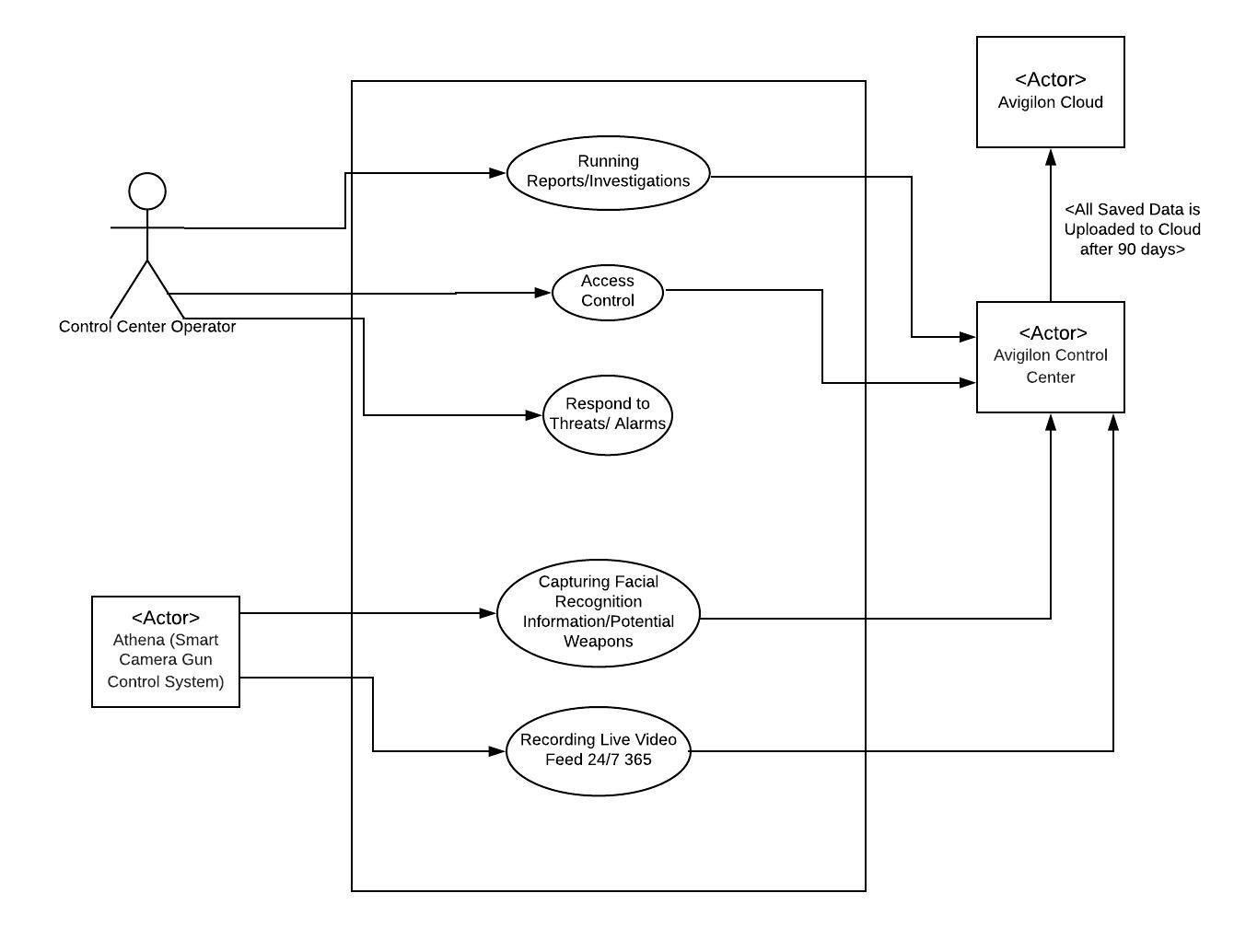

**Use Case Description:**

**Use Case Name**: Video Review

**ID:** 1

**Primary Actor:**  Control Center Operator

**Importance Level:** Medium

**Stakeholders and Interests**: Control Center Operator : Pull video feed/ Cloud Data

Avigilon Control Center/ Cloud: Workstation and data

**Brief Description:** A control center operator needs to pull video from the cloud to run an internal investigation about an incident.

**Trigger:** Internal

**Relationships:** Association: Control Center Operator and Internal video system Avigilon

**Normal Flow of Events:**

1. Operator requests for video using ACC Avigilon control center
2. ACC sends request to cloud or internal server to pull video
3. Operator reviews video

**Use Case Name:** Gun detection alert

**ID:** 2

**Primary Actor:**  Athena smart gun system

**Importance Level:** High

**Stakeholders and Interests:** Control Center Operator : Receives alert confirm or deny

Athena smart gun system : Camera and AI Sensors

Avigilon ACC: Review video of area zoom in etc

**Brief Description:** A control center operator receives an alert from the Athena system alerting of a possibly gun on BART property. The control center operator check Avigilon system for video playback of incident looks closely to confirm if unsure dispatch officer within 30 minutes.

**Trigger:** External

**Relationships:** Association: Control Center Operator and Athena smart AI analytics combined with Internal video system Avigilon

**Normal Flow of Events:**

1. Operator receives alert from Athena system of possible gun
2. Operator runs video review on Avigilon system to confirm presence of gun checks live feed also
3. Operator makes decision if threat is real or false and confirms using Athena App if confirmed law enforcement receive information and video of incident.
4. Patrol officer should be dispatch to scene within 30 minutes of incident if confirmed.

**Use Case Name:** Sensor Changes

**ID:** 3

**Primary Actor:**  Control Center Operator

**Importance Level:** Medium

**Stakeholders and Interests:** Control Center Operator : Sets sensors for custom reason

Avigilon Control Center or Athena: Workstation

**Brief Description:** A control center operator needs to set certain sensors on certain cameras to pick up specific activity for example loitering can be detected if a human is motionless for say 1 hour or so maybe they are sleeping on a BART bench at a station.

**Trigger:** Internal

**Relationships:** Association: Control Center Operator and Internal Avigilon ACM and Athena smart analytics sensors.

**Normal Flow of Events:**

1. Operator requests a certain camera depending on need gun detection, license plate capture etc.
2. Operator picks which sensors to enable and adjusts metrics to meet need for incident alert.
3. Operator tests sensor by dispatching a patrol officer to physically test cameras ability to make sure it is functioning properly.

**Use Case Name:** Access Control

**ID:** 4

**Primary Actor:** Control Center Operator

**Importance Level:** Medium

**Stakeholders and Interests:** Control Center Operator : Pull video feed/ Cloud Data

Avigilon ACM : Workstation and Physical Doors

**Brief Description:** A control center operator needs to set timers on certain doors to lock after non business hours also controller needs to set access levels for employees badges.

**Trigger:** Internal

**Relationships:** Association: Control Center Operator and Internal Avigilon ACM system / Physical Doors

**Normal Flow of Events:**

1. Operator changes time on automatic doors to lock after 6 PM daily during normal operational time this is done using the ACM system.
2. Operator then proceeds to make access levels for IT dept so they can only have access to certain doors during certain operational times.
3. Operator prints badges using ACM system for IT staff so they can use on daily basis.

**BART Security Operations Center Operator Dispatcher Rule:** You are required to acknowledge/respond to alarms within 5 minutes of them popping up. A video review should be done within 10 minutes if a threat or situation is deemed dangerous, then officers/medical personnel should be dispatched. A total response time should be no more than 30 minutes or this will result in a write up for the operator dealing with the situation.1st write up will result in a verbal warning, second write up will lead to a 14 day suspension and evaluation period, third write up for failure to meet 30 minute mark will lead to termination pending on review.

**Avigilon ACC (Control Center) Example:**

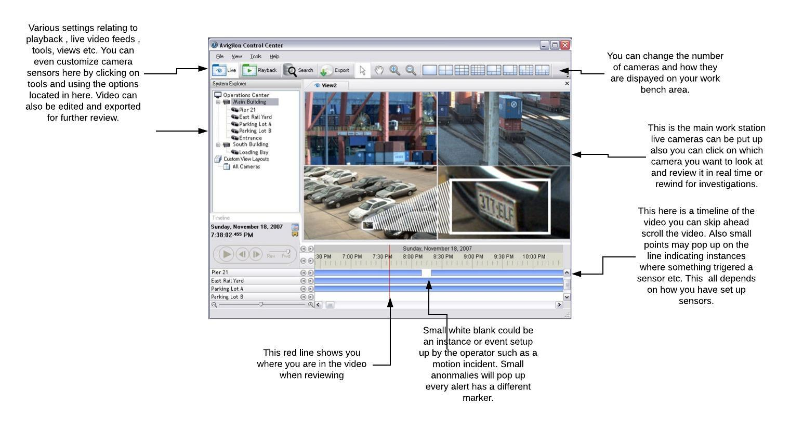

**Avigilon Artificial Intelligence Sensors:**

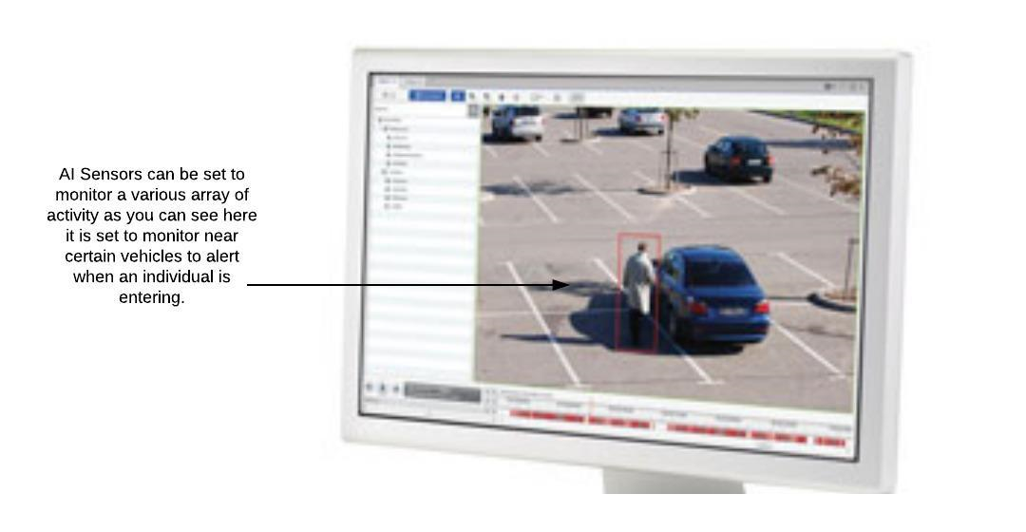

**Avigilon ACM (Access Control Manager) Example:**

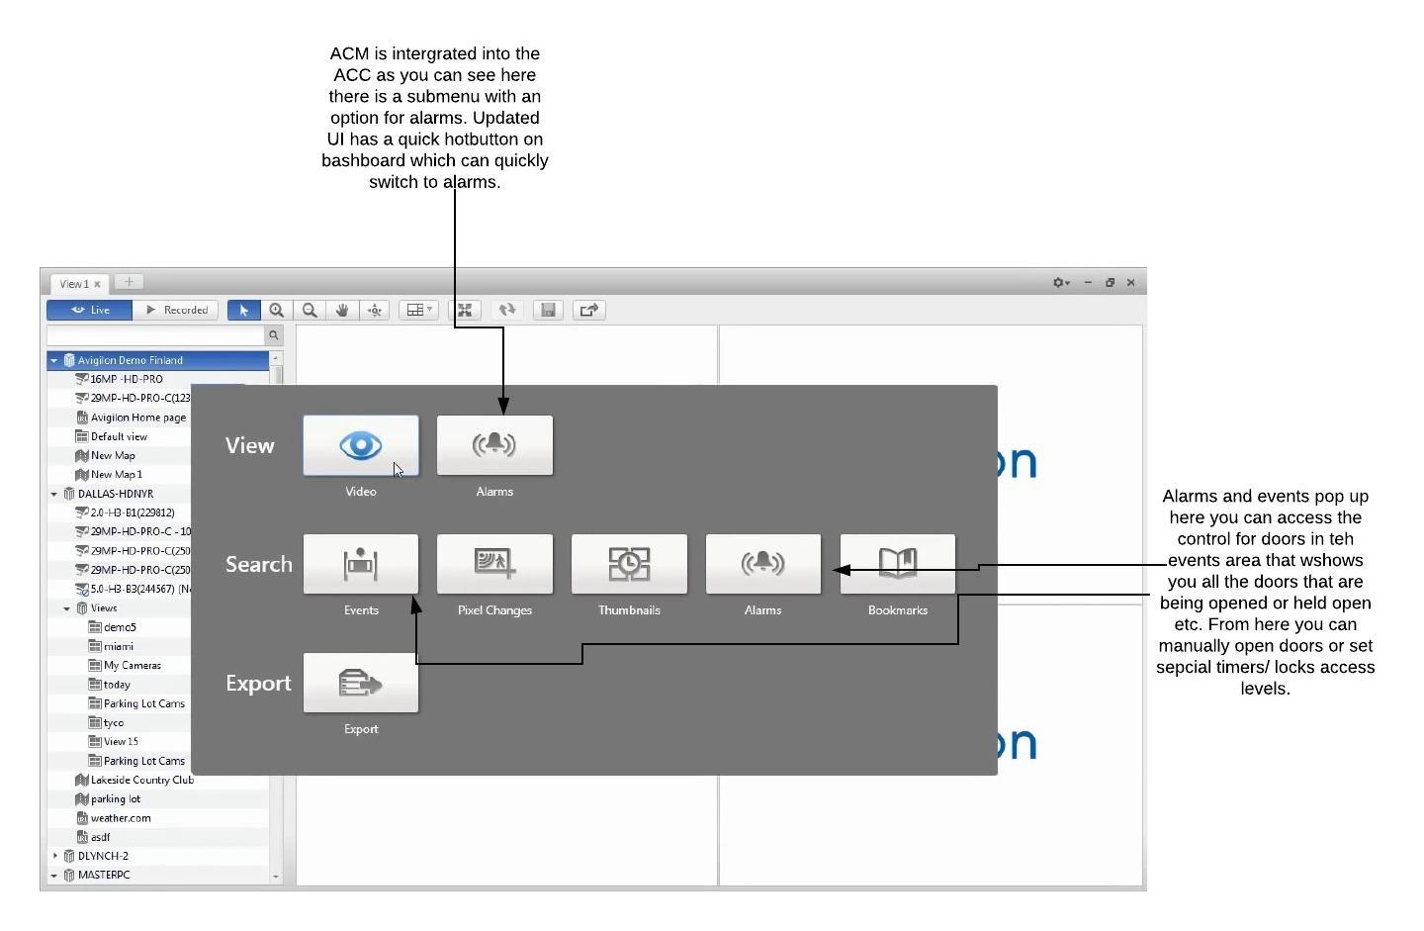

**Avigilon ACM Integrated System for Access Control:**

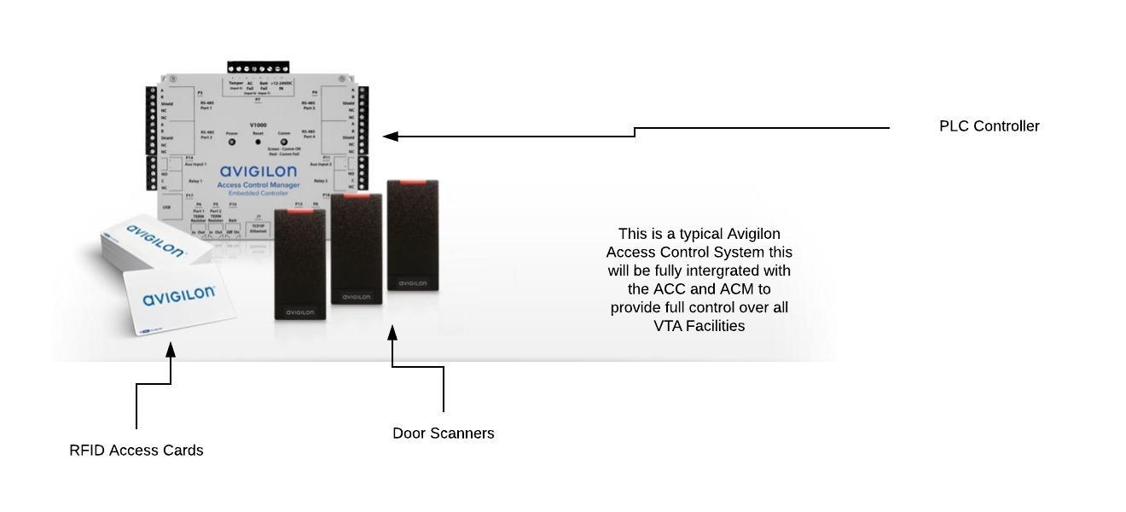

**Athena AI Sensors:**

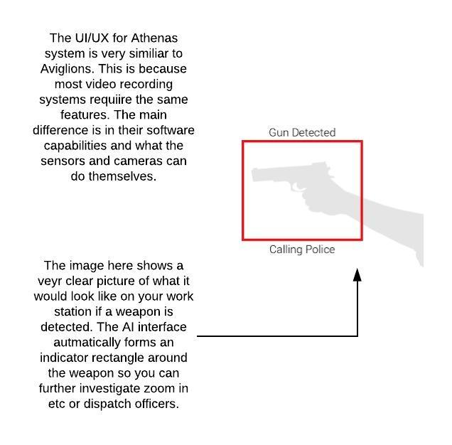

**Athena Smart Weapon Detection Alert:**

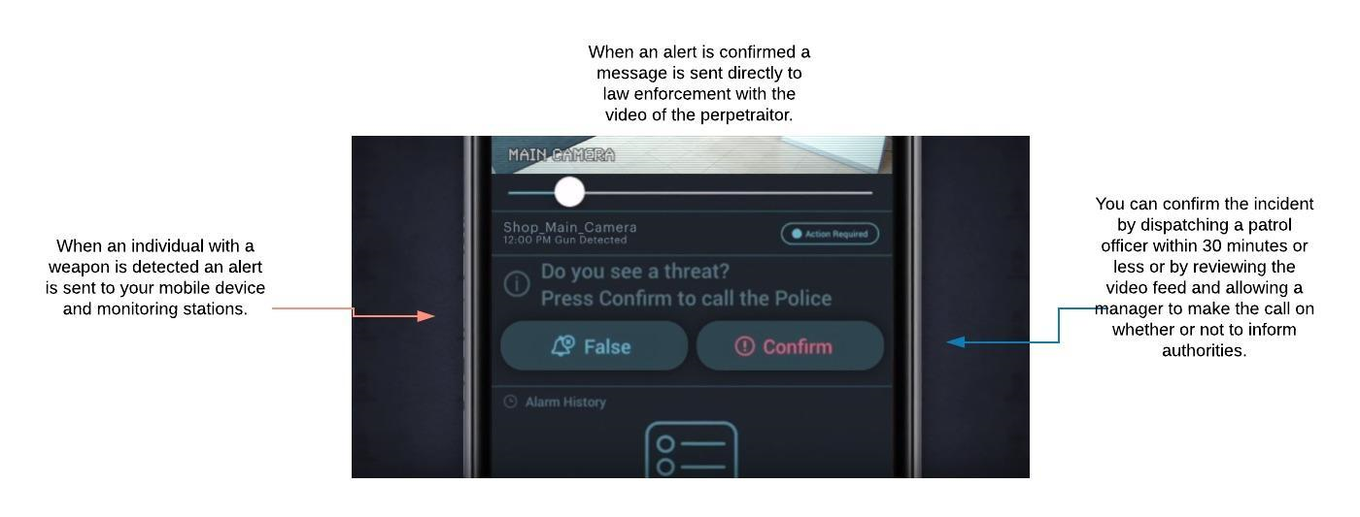

**Scope Change Process**

KNBMS Technical Consulting recognizes that this project may need to modify or extend the agreed upon scope definition due to unforeseen circumstances such as lack of funding/or other reason (s) deemed acceptable. Users and/or clients may feel obliged to modify the project’s scope statement. KNBMS requires a complete scope plan along with the modified scope date in order to continue this project.

To keep KNBMS as efficient as possible, we require every change made in the scope plan to be documented below using a scope change request form. These requests will be reviewed and will either be denied or accepted on a per request basis. We require that all members of KNBMS enter their requests into the Scope Change Log below. All sections of the log must be completed as required for requests to be taken into consideration

**KNBMS Technical Consulting**

**Scope Change Request Form**

**Version: 1**

**Date of Request:**

|  |
| --- |
| **Scope Change Request Form** |
| **Project Name:**  **Client Name:** |
| **Change Request No:**  **Date of Request:**  **Request Prepared By:**  **Request Approved By:**  **Request Rejected By:**  **Reason for Request Rejection:**  **Title:**  **Date Approved/Rejected:** |
| **Description of Requested Change/Alternative** |
| **Change Request: Explanation for Change: Priority (low,medium,high):**  **1) - -**  **2) - -**    **3) - -** |
| **Problems Expected to Arise if Change is Not Made** |
| **Problem 1:**  **Problem 2:** |

**Work Breakdown Structure**

**Work Breakdown Structure:**

Our project life cycle and system development life cycle phases and deliverables have been previously stated in our deliverable structure chart of the Scope Management Plan. The Milestones, Deliverables, Deliverable Milestones and the Activities/Tasks that need to be performed to achieve the milestones are below. KNBMS used the estimation techniques, time boxing and bottom-up these helped create our time estimations for the different tasks in the WBS.

**Project Phases – Tasks, Deliverables and Milestones:**

The chart below features all the tasks, major phases, milestones and durations for the BART Physical Security Information Management System project. The table also states resource assignments and lists out the approximated time to complete each task.

**Estimation Techniques:**

KNBMS Technical Consulting utilized a variety of estimation techniques to compile the time estimates of the activities and tasks in the Work Breakdown Structure. In order to estimate the various times listed below, we used time boxing and the bottom-up estimation technique to come up with duration times for each task. KNBMS found the time boxing and bottom-up estimation technique to be very useful for our WBS report. Time boxing allows for a very clear and concise time frame for every step of the project this is why we choose to use this. Bottom-up approach was also very effective because we received real information from the people who do the work so this correlated well into real time estimations.

|  |  |  |  |  |
| --- | --- | --- | --- | --- |
| WBS | Task Name | Milestone | Duration | Resource Names |
| **1** | **Physical Security Information Management System Project** | **No** | 365 days |  |
| **1.1** | **Initialize and Conceptualize** | **No** | **75 days** |  |
| 1.1 | Identify and Arrive at MOV | No | 15 days | Project Manager,Sponsor |
| 1.2 | Alternatives Identification and Feasibility Analysis | No | 15 days | Project Manager, Sponsor, Software Support |
| 1.3 | Deliverable: Business Case | No | 25 days | Project Manager |
| 1.4 | Client Approval of Business Case | Yes | **110 days** | Sponsor |
| **2** | **Plan Project** | **No** | 20 days |  |
| 2.1 | Define Project Scope | No | 10 days | Project Manager, Systems Architect,Sponsor |
| 2.2 | Deliverable:Create Scope Management Plan | No | 15 days | Project Manager,Systems Architect |
| 2.3 | Deliverable:Create Communication Plan | No | 30 days | Project Manager |
| 2.4 | Define Project | No | 30 days | Project Manager |
| 2.5 | Identify Tasks | No | 50 days | Project Manager,Systems Architect |
| 2.6 | Estimate Budget and Schedule | No | 80 days | Project Manager, Process Improvement |
| 1.2.7 | Deliverable:Create Baseline Project Plan | No | 30 days | Project Manager |
| 1.2.8 | Client approval on Baseline Project | Yes | 20 days | Sponsor |
| **1.3** | **Execute Project** | **No** | **50 days** |  |
| 1.4 | Business Meeting | Yes | 50 days | Project Manager, Systems Architect, Sponsor, SME, TESTERS |
| **2** | **Analysis** | **No** | **90 days** |  |
| 2.1 | Physical Security Information Management System (PSIMS) Analysis | No | 20 days | Project manager, Software Support |
| 2.2 | Plan Requirements Gathering | No | 30 days | PSIMS |
| 2.3 | JAD Sessions for Requirements Gathering | No | 30 days | PSIMS, Executive Sponsor |
| 2.4 | Analyze Requirements | No | 60 days | PSIMS,Technology Support |
| **3** | **Document Requirements** | **No** | **80 days** |  |
| 3.1 | Business Cases | Yes | 60 days | PSIMS |
| 3.2 | Speculations Report | Yes | 20 days | Systems Architect |
| 3.3 | Client Sign | Yes | 50 days | Sponsor |
| **4** | **Implement the System** | **No** | 10 days | Sponsor |
| **5** | **Develop Logical Design** | **No** | 50 days |  |
| 5.1 | Deliverable:Develop ERD, DFD, And other diagrams | No | 80 days | Software Support |
| 5.2 | Deliverable:Design Document | No | 20 days | Software Support |
| 5.3 | Verify adherence to MOV and Requirements | No | 30 days | Project Manager,Software support |
| 5.4 | Client Sign off | Yes | 50 days | Sponsor |
| **6** | **Construction and implementation** | **No** | **25 days** |  |
| 6.1 | Set up | No | 3 days |  |
| 6.2 | Verify MOV and Requirements with developed system | Yes | 20 days | Project Manager,Software support |
| 6.3 | Implement new hardwares |  | 2 days |  |
| **7** | **Testing** | **No** | **9 days** |  |
| 7.1 | Create user test environment | No | 2 days | Developer, Project manager, Software support, TEchnology Support |
| 7.2 | Analyze test results | No | 2 days | Process improvement |
| 7.3 | Client Sign off | Yes | 5 days | Sponsor |
| **8** | **Releases** | **No** | **200 days** |  |
| 8.1 | Create Implementation Plan | No | 20 days | Systems Architect |
| 8.2 | Create user environment | No | 20 days | Developer |
| 8.3 | Prepare User Training Programs | No | 30 days | Technology and software |
| 8.4 | Conduct user training | No | 50 days | Project Manager |
| 8.5 | Release PSIMS | No | 50 days | Project Manager, |
| 8.6 | User trainings | No | 25 days | Project Manager |
| 8.7 | Client sign off | No | 5 days | Sponsor |
| **9** | **Close Project** | **No** | **56 days** |  |
| 9.1 | Prepare final report and presentation | No | 14 days | Project Manager |
| **10** | **Evaluate Project** | **No** | **14 days** |  |
| 10.1 | Lessons Learned | Yes | 7 days | Project Manager |
| 10.2 | Evaluating MOV | Yes | 7 days | Project Manager, Technology and software support ,Sponsor |

GHANTT Chart

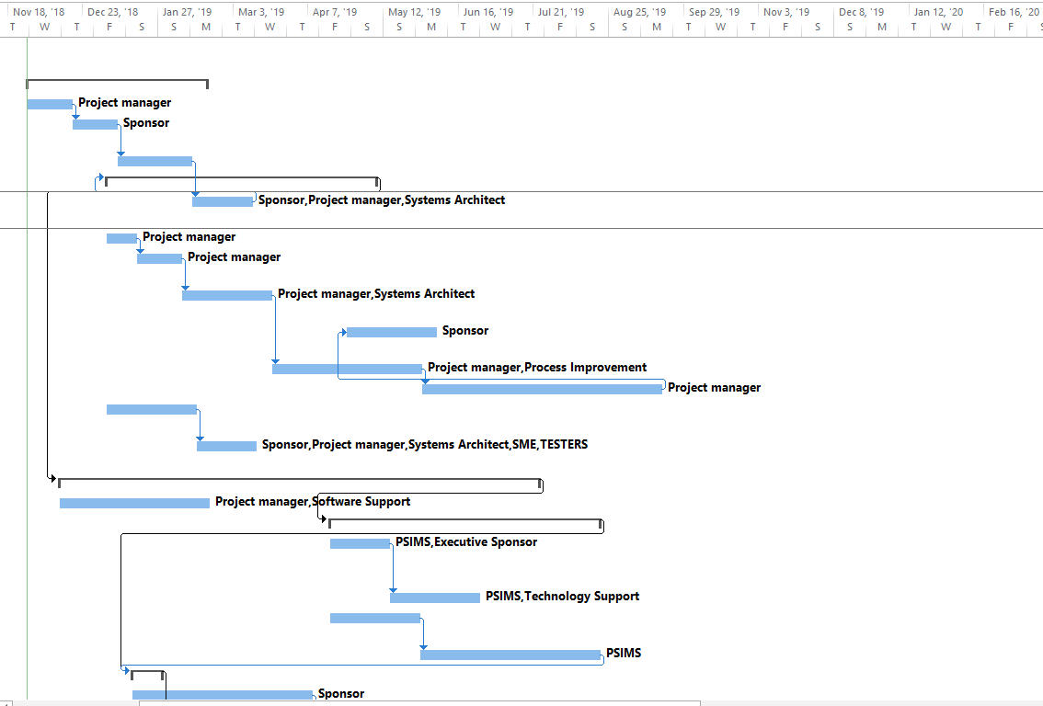

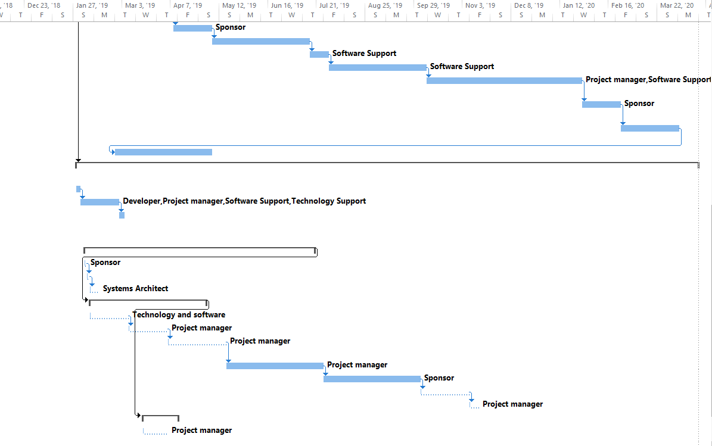

**Budget:**

The budget we have proposed is $2,722,800. KNBMS understands the overall high budget we have proposed, however when you look into BART’s overall revenue you will see they are turning over millions of dollars. The proposed cost of $2.7 million is a small fraction in the big picture of BART.

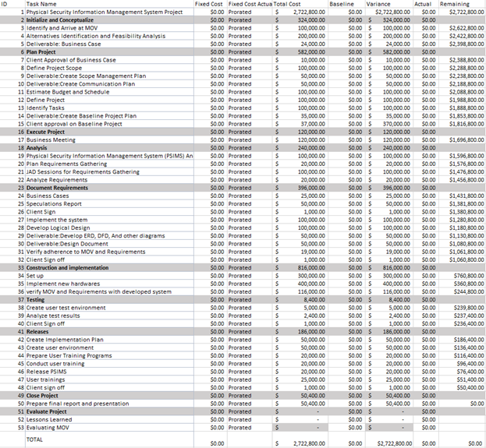

**Acceptance and Approval:**

The signatures below indicate acceptance and approval of the Work Breakdown Structure of the PSIMS project and its estimated schedule.

|  |
| --- |
| **Title/Role Name Signature** |

**Executive Sponsor Harneik Dhanota ________________________**

**Technology Support Simranjeet Kaur ________________________**

**Process Improvement Kerwin Garcia ________________________**

**Project Manager Monisha Kaur ________________________**

**Software Support Brixton Pizzuti ________________________**

# **Project Schedule/Budget:**





**Project Budget:**

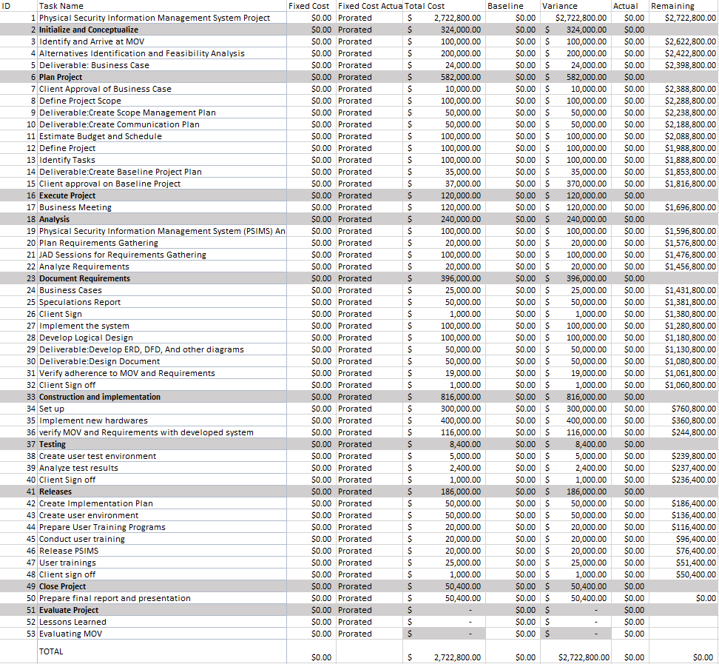

# **Assignment Questions:**

1. **What are beginning and end dates for your project?  How many days will it take to complete the project?**

Project Beginning Date: September 21, 2018

Project End Date : September 21, 2019

Total No of Days : 365 days

The project started September 21, 2018 and estimated that will end September 21, 2019. This system wide implementation could take 12+ months. We started this project on September 21st 2018 and estimated that will end September 2019.

1. **Does your project have a single or multiple critical paths?  What is the importance of the critical path?**

Our project has a single critical path. The importance of a critical path is how it allows teams to understand what the most important parts of their project is, and how they can accomplish those tasks in the shortest amount of time possible. Using the critical path method, we can compare our planned progress to our real-time current progress.

1. **What is the total budget of your project?**

KNBMS Consulting PSIMS project looked into cost-efficiency. In order for Collection, Analysis, Resolution, Reporting, Audit trail, our tools to sustain reduction for criminal activity would cost $2,772,800. As illustrated above the tasks consist of execution, testing, analysis, releases and others mandatories that take effect a total of 365 days.

**Lessons-Learned Report**

**Date: 12/10/2018**

**Project Name: BART Physical Security Information Management System**

**Project Sponsor: Bay Area Rapid Transit (BART)**

**Project Manager: Monisha Kaur**

**Project Dates: 09/21/18-09/21/19**

**Final Budget: $2,772,800**

**1. Did the project meet scope, time, and cost goals?**

Yes, our project successfully met scope, time and cost goals.

**2. What was the success criteria listed in the project scope statement?**

Our success criteria was to enhance over 1,500 analog cameras to fully digital format. As a result, this would create stronger communication among dispatch, police officers, and BART officials through our cutting-edge technology. Additionally, the monitoring of any suspicious/criminal activities 24/7 will lead to overall reduction of crime. Through the utilization of our advanced surveillance technology, we aim for a goal of safer transportation for all BART riders.

**3. Reflect on whether or not you met the project success criteria.**

We did meet project success criteria. We successfully enhanced/implemented 1,500 analog cameras to a fully digital format. This implementation increased public transportation, and lowered crime rate in BART stations/surrounding areas as a whole. KNBMS also received positive feedback from our client (BART). BART has increased their ticket/fare sales as well as overall revenue through enhancing their security/surveillance. This feedback contributes greatly to the success of our project.

**4. What were the main lessons your team learned from this project?**

Our team worked well with limited supervision and the main lessons we learned is that in order to have a successful project everyone must contribute their individual part. When someone cannot complete their part of the project due to an emergency, it is important to have other group members who you can rely on to finish the project.

**5. Describe one example of what went right on this project.**

One example that went right during this project was the use of external communication in order to interact and assign tasks for the project. We didn’t rely on purely class time to structure and execute the project.

**6. Describe one example of what went wrong on this project.**

One example that went wrong during this project was the conflicts with each others schedule, there were times when we couldn’t meet up in person and then one person would be responsible for going to the computer lab to use MS project and complete that part by themself.

**7. What will you do differently on the next project based on your experience working on this project?**

On the next project, we will assign all of the tasks beforehand and make sure every group member understands what tasks they have to do and when they have to do them by.